You need to activate the GD graphics library in the php.ini. Most free hosting services won’t let you do it.

Once you are done creating you GD, the php script won’t return a html view, but an image. You start by specifying the header function, tehn provide all the info about the image and close up the script by using the imagepng($image) function

http://i.gyazo.com/db5128203f11027c3c2189bfab88f86a.png

So, basically, the script is not gonna contain any tags or html code, but instead info about the image, that’s why the header is gonna be in jpg format. The image itself is going to be stored as a variable.

http://i.gyazo.com/602078428b088368780fbe4ec2dba5de.png

This is for when you want to create an image from scratch. If you wanna create an image from an existing one, use either the imagecreatefromjpg or imagecreatefrompng functions

http://i.gyazo.com/76cd28b87f8844db87b93125b5f8038a.png

How do you display it? Simply call it from a HTML tag:

http://i.gyazo.com/db7081511ee83e41289db846bde75180.png

Maybe you just wanna save the image on the hardrive or the server. IN that case, you pass the location you want for it as a parameter in the imagepng() function and then call it in HTML as a png file.

http://i.gyazo.com/95e55fab615dd368e6efe94bb40b0da4.png

**Manipuler des couleurs**

You have to first define the colors you wanna use for your image as variables using the imagecolorallocate() function

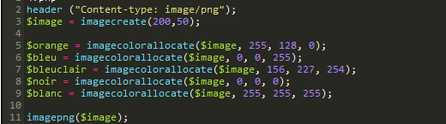

One thing to remember: *the first color defined will become the background color for the image, the second color determines the font color.*

**Writing text**

http://i.gyazo.com/1dc15e454e0d2506f627b530667a5858.png

**Fusionner deux images ensemble**

You gotta first define both of them and then say with destination x, y where the second image is supposed to go, and finally you use the **imagecopymerge()** function.

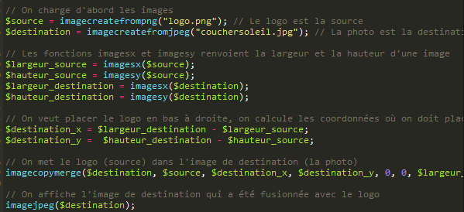

Now, you can automatically copyright every picture you upload!